OFFICIAL COORDINATION REQUEST FOR
NON-ROUTINE OPERATIONS AND MAINTENANCE

COORDINATION TITLE- 12LWG 006 new barge moorage facility
COORDINATION DATE- 14 June 2012, revised for 12 July 2012
PROJECT- Lower Granite Dam Smolt Transportation Section 7 and Section 10 Permits
RESPONSE DATE- 14 June 2012
Description of the problem – The Corps proposes to construct a new deep foundation piling supported moorage facility and mooring dolphin that will accommodate up to eight (8) of the larger 8000 Series fish transport barges. The purpose and need of this new fish transport barge moorage facility and dolphin is to add to the existing moorage facility located along the shoreline of the Lower Granite earthen fill section to accommodate O&M and repairs of the existing barge fleet, replacement of existing barge equipment and/or additional barges, and improve simultaneous access to multiple barges for transferring high weight supply.

The Lower Granite Dam serves as the O&M hub for the existing Federally-owned Juvenile Fish Transportation barges, where maintenance, repairs, and over wintering of barges occurs. The fish transport barges require essential maintenance to be routinely performed that include ensuring all engines and circulation pumps are maintained and in good operating condition; ensuring fish release openings and related equipment operate properly; removing inside edges off joints, cleaning holding tanks, removing and installing net pens in barge holds for transport of steelhead kelts or other isolated populations; installing oxygen monitoring probes and testing monitoring system operation for water temperature, dissolved oxygen, and de-gassing of total dissolved gases (TDG) supersaturation.

Currently an existing moorage facility sits immediately north of the Lower Granite Dam Navigation Lock and approximately 300 feet (ft) southwest from the new proposed location. Due to its configuration, the existing facility limits the number of barges that can be serviced at one time due to their moorage tied 3-4 barges abreast, thus restricting the reach of necessary equipment required to maintain, repair, or supply the barges, such as cranes. Most equipment must be carried by human hand over multiple barge railings and gunwales. The existing moorage facility was designed for six (6) barges, but routinely moored all eight (8) barges upon the completion of constructing the newest replacement barges of the 8000 Series. The newest replacement barges have become larger in size and capability, but at least two (2) barges had to be moored and stored on the upriver navigation lock wall when not in-service. However, due to lack of adequate alternate moorage facilities at other Dam locations, and frequent routine and non-routine maintenance required, currently eight (8) fish barges are frequently tied to the existing Lower Granite moorage structure. The current configuration requires the affected fish transport barges be directly adjacent to the mooring cells for crane access and moving any heavy equipment and machinery on or off the barge. This often requires additional resources (e.g., tugs and lockages upriver/downriver) to shuffle and relocate barges for adequate access to the affected barge, throughout the year. This takes a significant amount of time and labor to move barges around.

Although, a couple of the smaller original barges were to be retired, the transport program needs for direct loading at multiple dams and research has retained most of these older and smaller barges of the 2000 and 4000 Series. These limitations in accessible mooring have affected timely repairs, which in turn can negatively affect fish transport operations.

The action area is the “cul-de-sac” located immediately on the downriver side of Lower Granite earthen fill section between the navigation lock and the north shoreline. The action area is a footprint of about 5.5 acres in size, of which about 1.5 acres is directly related to the new moorage wharf coverage (0.1 ac) and intermittent shading of docking and smolt migration off-season storing of 8 barges (1.4 ac).

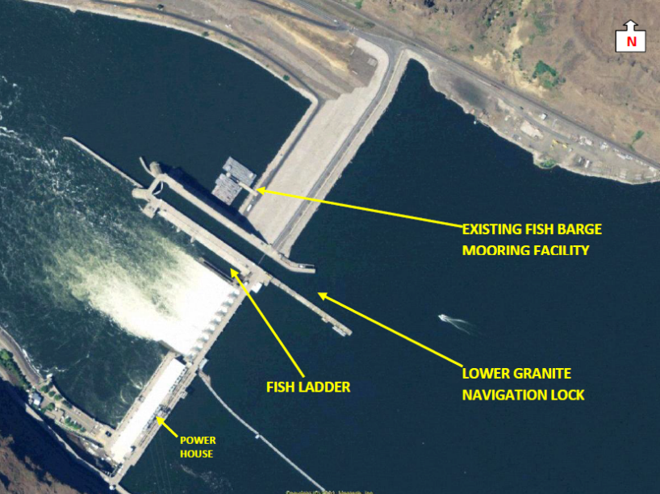
Figure 1. Aerial view of the Lower Granite Dam, navigation lock, fish ladder, in relation to the existing fish barge mooring facility located adjacent to the north side of the navigation lock, and immediately downstream of the toe of the earthen portion of the non-overflow dam.

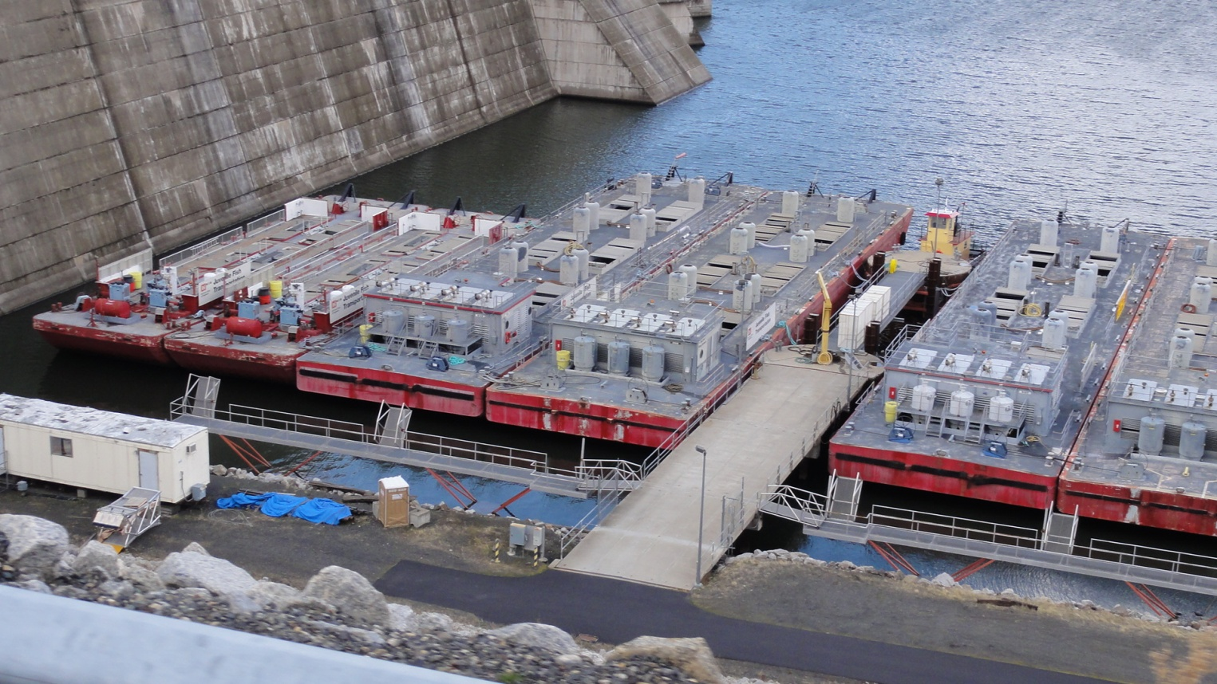
Figure 2. Existing fish transport barge mooring facility has limited access to barges which restricts necessary services (heavy equipment operations) to those that are immediately adjacent to the existing structure.

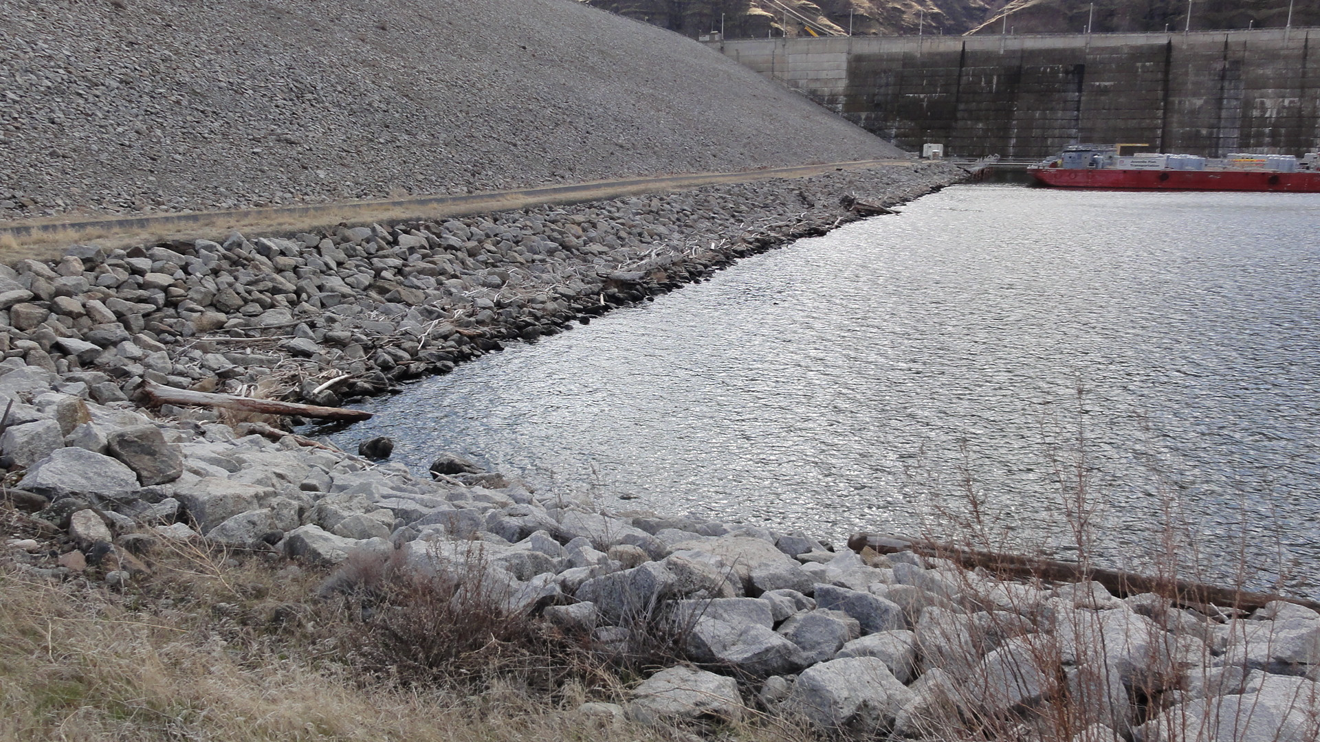
Figure 3. Existing moorage facility in background; foreground represents location of the proposed north shore and toe pile support fish transport barge facility. Access road is located along top of the dam toe (left, road runs parallel with shoreline)

The new moorage facility is basically a wharf approximately 400 ft in length, and positioned parallel and along the toe of the earthen fill section.

The new wharf will be built over the toe of the earthen fill on two rows of 4.5-ft diameter drilled shafts (one row of 16 pilings located on shore and a second row of 16 pilings located in water); precast concrete cap beams, and pre-stressed precast concrete slabs. The toe slope is protected by riprap, which will require some removal during construction phase. Other work such as excavation, clearing, grubbing, and trenching for utilities will occur simultaneously with pile (shaft) installation. The on-shore and in-water pile supports, concrete caps and slabs are connected together by a final 6-inch cast-in-place concrete closure pour. The wharf will extend out into the river approximately 40-ft from shore. The overall footprint of the wharf would be less than 0.39 acres with < 0.1 acre over-water. During the juvenile fish passage season of April through August when the reservoirs are operated at Minimum Operation Pool (MOP) water surface elevation of 633’, the wharf will cover approximately 6-8’ of water depth with about 20’surface water to shore under the wharf. At Full Pool water surface elevation of 638’, the wharf will cover approximately 11-13’ of water depth with about 30’ surface water to shore under the wharf.

Type of outage required – None, all winter in-water work window 15 Dec 2012 through 1 March 2013.

Impact on facility operation – None anticipated, positive effect on timeliness of needed repairs; and pre-season and in-season O&M on 8 smolt transport barges to maximize their availability, reliability, and rotation for direct loading and AFEP research objective treatments from any of the three Snake River smolt collection and loading facilities.

Dates of impacts/repairs - Winter in-water work window 15 Dec 2012 to 1 March 2013.

Length of time for repairs (construction) – 75 days

Expected impacts on fish passage – No negative effects anticipated on adult (overwintering delayed steelhead) or juvenile passage due to construction and completion during scheduled winter in-water work and no changes to FPP and FOP operations.

Downstream migrating juvenile salmonids:
Smolt monitoring season concludes on 31 October and the LGR JFF closes 15 December, so it is reasonable to believe very few juvenile salmonids will be migrating during construction 15 December – 28 February. Of those that may be in the LGR tailwaters, predominantly Snake River subyearling Chinook salmon holdovers (presumably Clearwater River origin dominant), no anticipated or planned change from current winter passage through unscreened units of the powerhouse unless for involuntarily spills that would occur for in-river flows >100 kcfs.

Downstream and upstream passage of adult salmon and steelhead:
No significant impacts expected. The majority of overwintering adult salmonids that are observed wandering above and below the lower Snake River dams are either A or B-run steelhead that pass in mass upon ladder opening in early-March (Figure 1). Screens are typically left in place through 15 December to prevent adult salmonids from falling back via turbines. Beginning in early November through 15 December, a small number of fallbacks may include fall Chinook salmon, coho salmon, and steelhead. After 15 December the only available passage route is operating unscreened turbine units. Annual and 10-yr average passage data from USACE Annual Fish Passage Reports and/or www.cbr.washington.edu/dart/adultpass_all.html indicate that January and February passage was only counted during the mid-1970 years immediately following Lower Granite Dam closure when in 1-of-5 years (1978) showed that less than 500 steelhead passed during January, followed by a slight building up in passage to about 800 more fish in February. Accounting for annual variation and spikes in March through December ladder counts since the 1970s, a substantial decline in passage typically occurs during mid December without any discountable increase until about 1 March when the ladders are re-opened. The time this construction would occur, the winter in-water work window of 15 December through 28 February, does see less than 1000 steelhead (green line below in Figure 1 when ladder initially re-opens, representing 0.1 to 1.6 percent of the total annual adult steelhead passage at LGR) wandering the tailwaters. These fish are delayed or fallen back searching around the dam concrete (powerhouse and spillways where upstream attraction hydraulic conditions remain) for ascension when an upstream route is available during Januray and February. The earthen fill section is relatively isolated behind the navigation lock walls with <1 fps velocities providing no upstream attraction hydraulic conditions, so zero to maybe a couple adult steelhead may find the construction zone for brief periods of time during January and February.

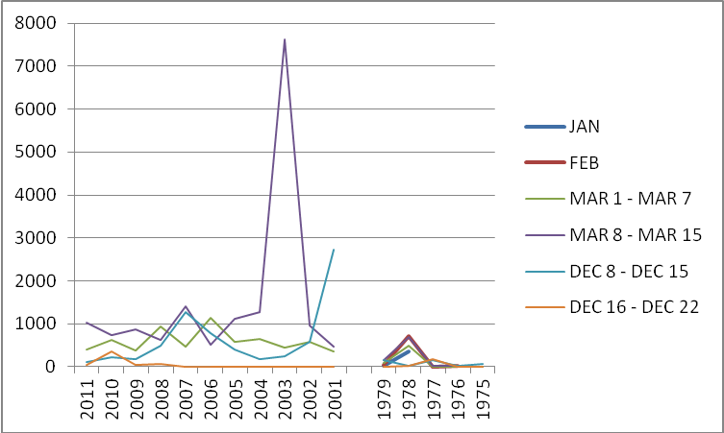
Figure 1. Annual number adult salmonids passing LGR ladder during winter in-water work window (Data Source: USACE Annual Fish Passage Reports).

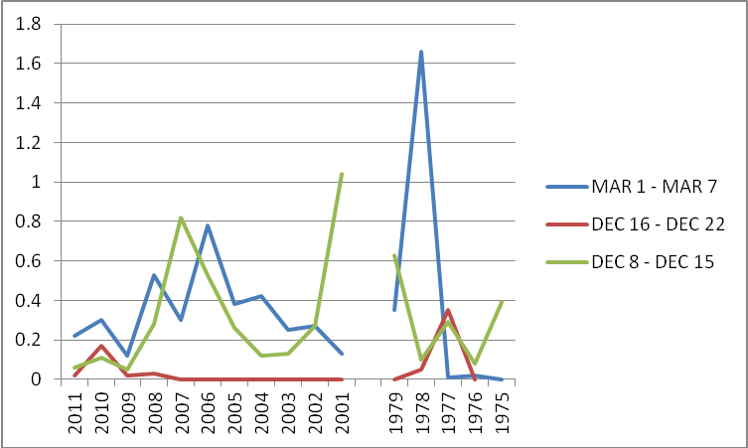
Figure 2. Percent of annual outmigration of adult salmonids passing LGR ladder during weeks around winter in-water work window (Data Source: USACE Annual Fish Passage Reports).
The expected effects of pile driving on fish can be generally summarized as disruptions of normal behavior. The shock waves generated by pile driving could potentially disrupt the foraging behavior of fish, cause them to move away or exhibit a startle response, or delay migratory progress.

Salmonids are capable of detecting the sound of drop-hammer pile driving at least 1,969-ft (600 m) (about 0.4 mile) away, and sound can be at least 20 dB above ambient levels at 1,946-ft (593 meters) (about 0.3 mile). Fish likely would not change their distance from shore or cease foraging in response to pile driving. Sound levels associated with heavy construction equipment can range from 80 to 120 decibels (dB) at about 100 feet. Background noise generated by the operations of the Lower Granite dam can greatly assist in masking sounds generated by the proposed construction activities. The 10-ft casing surrounding the 4.5-ft pile structure will assist in buffering/reducing noise transfer to the surrounding environment generated by the drilling, and tapping casings into place. As a further means to reduce in-water noise, a vibratory hammer will be used. In the event that an impact hammer must be used, adequate damping devices between the hammer and the casing will be required.

Construction lighting associated with this project is necessary and a safety requirement. Due to the time of year when construction activities will begin (December), shorten daylight hours will require the work area to be lighted. Such artificial lighting during normal winter dark hours may act as an attractant for fish that ceased foraging for the day, causing fish to move towards the shallower water depths of the construction site, or temporarily altering fish foraging behavior.

All FCRPS are well lit with artificial lights during each night, so background light may be minimal to moderate during the winter construction months in the action area. To minimize potential affects construction lighting will only be used when necessary and will be turned off immediately when no longer needed via motion detectors and timers. The Corps believes work barge activities and equipment movement will most likely deter or cause fish to move out of harm’s way, thereby reducing potential effects to fish in the immediate work area.

Shallow water functions as a refuge for small fish, especially in the absence of complex habitat features such as woody debris or submerged vegetation. These shallow habitats with low velocities and slopes offer juvenile fish refugia from predatory fish that may be too conspicuous to enter very shallow depths. Several studies have shown lack of predation in reservoir littoral zones without cover from structure making these safe places for small fish to rear and feed. However, the Lower Granite earthern fill cul-de-sac shoreline is riprap dominated that provides cover for piscivorous predators such as smallmouth bass.

Near shore (littoral) habitats are not just important for juvenile rearing but are also important to predators. Various studies suggest new pilings provide structurally simple habitat elements that provide cover and structure to spawning and foraging predators. For example, smallmouth bass, and to lesser extent northern pikeminnow, are attracted to the cover that over-water structures provide (Bellgraph et al. 2012). These predators gain an advantage over prey fish in structurally simple environments, which is substantiated by findings that bass (especially smallmouth bass) persist or thrive along developed shorelines, while other species decline. Over water structures provide a darkness edge and contrast zoning preferred by sight-predator fish such as smallmouth bass.

Because of the shading effect created by pile support structures, there is ample scientific literature to support the notion that migratory juvenile fish may avoid such overhead cover and instead maneuver along the edges rather than penetrate them. Studies suggest this behavior is size related, with smaller fish being most likely to avoid traveling through shaded habitat.

A minor decrease in the abundance of epizootic macroinvertebrates on submerged rock that could be seasonally available for foraging salmonids may occur in the immediate vicinity of the in-water work activities for a period of a few days to the duration of the growing season as a result of turbidity from construction and permanent shading of ~0.1 acre of the existing shallow water photic zone. The effects will be shorter-term and inconsequential.

The FPP surface water elevations across all zones of Lower Granite Dam during the fish passage season at MOP and outside-of-season within the Full Pool range of elevations would not change for any flow year as a consequence of constructing a new moorage wharf, so water quality and quantity in the cul-de-sac would be maintained at background levels.

Pacific Lamprey (Lampetra tridentata)
Lamprey spend most of their life as small ammocoetes in stream sediment, feeding on algae and small organisms. There is no suitable habitat with respect to preferred rearing substrate of silt and sand in the project area. The project footprint pre-dam was fluvial shoreline composed of gravel and cobble, so no juvenile lamprey are expected to be present in the project footprint. After five to seven years, lamprey mature and migrate out as macropthalmia to the ocean. Migration timing and numbers of juvenile lamprey have been poorly understood based upon limited data collection. Most juvenile lamprey in the Snake River have been collected in turbine intake water strainers during February, so juvenile lamprey do migrate through Lower Granite Dam during the in-water work window of 15 December – 28 February, but would be confined to migratory habitat and conditions associated with dam passage routes and not dead water (water velocities <1 fps) and shallow water shoreline zones such as the project area. Adult and maturing lamprey live in the ocean for two years or so, where they mature into adults and become parasitic on larger fish and marine mammals, before detaching from their host and returning upriver to spawn in the spring. Only a few adult lamprey have been recorded in recent years returning upriver through Lower Granite Dam fishways and they would be confined to migratory habitat and conditions associated with dam passage routes and not dead (water velocities <1 fps) and shallow water shoreline zones such as the project area.

Comments from agencies –
NMFS – Complete all in-water work and work accessed from water during the winter in-water work window 15 Dec 2012 to 1 March 2013.
NMFS – Long-term benefit to ESU/DPS stocks adult return rates due to smolt transportation needs to justify short-term impacts and long-term effects to ESU/DPS stocks adult return rates due to having wharf present.
BPA- Not excited about the proposed project, but OK the FPOM coordination form. Request if any cost/benefit analysis has been completed. ACTION: Pinney will find any alternatives study that would have looked at the cost/benefit of the project. RESPONSE: No feasibility study has been initiated or completed on this proposed action by the Corps. In the 1990s, the LGR project had a need requested to the Walla Walla District for improved functionality and safer barge mooring when it became evident that LGR was the smolt transportation hub for both operation and maintenance, since LGR was the initiating project for smolt transport and smolt tagging, as well as the project that transported the most smolts collected. Prior to the original design of the existing moorage facility and the initial design of the proposed moorage wharf in 2002, other project locations such as Little Goose was discussed regionally, but rejected based upon transport program planning that LGR would likely be the most permanent transport loading project on the Snake River while the region was developing spill and better bypass operations. Again in 2008 when funding was sought for design and construction, there was no regional request for a change in location or study of location alternatives, so the project landed on the conditions of the original LGR need request for 2012.
OTHERS, FPOM open forum discussion:12LWG06 Barge mooring construction. Pinney gave a .ppt presentation of the MOC. The design is at 90% review. The in-water work will be confined to the IWW window. If there is a need for an extension, NWW will bring this back to FPOM. Lorz provided a critique of the fish impacts. He would like to see lamprey and the detailed fish passage numbers. He suggested the impacts are to layout potential negative impacts; potential positive impacts from the construction do not really belong in the fish impacts section. Lorz suggested this go to the Lamprey Task Group for documentation on lamprey impacts. Pinney noted that the USFWS BA needs to be edited to include Bull Trout. Fredricks said placing and pile-driving aren’t going to affect anything other than predator habitat; do NOT blast. Conder asked about the concern about curing concrete in 40F or below. He asked how comfortable will the Region be with pulling forms after the IWW. Bettin asked if a cost/benefit analysis has been completed. Kiefer asked if there was any concern with impacts to adult passage. Setter assured him there shouldn’t be an impact to adult passage. BPA is ok with changing the work window but not excited about the project itself. FPOM was in agreement that this project isn’t a high priority but there was finally money in CRFM to do the work. RESPONSE: Additional fish impacts/effects from Biological Evaluations and Biological Assessment added in text above to address FPOM questions and concerns.

Final results –
12LWG06 Barge mooring construction. Approved. FPOM was in agreement that this project isn’t a high priority but there was finally money in CRFM to do the work.

Please email or call with questions or concerns.
Thank you,
Figure A. LGR Transport Barge Moorage site plan. NOTE: “L-shaped” extension running parallel to shoreline has been removed from final design reducing the structure by about 35%.

Figure B. LGR Transport Barge Moorage pile structure. NOTE: “L-shaped” extension running parallel to shoreline has been removed from final design reducing the structure by about 35%.

Figure C. LGR Transport Barge Moorage cross-section through earthen-fill.

Figure D. LGR Transport Barge Moorage Dolphin details and section.

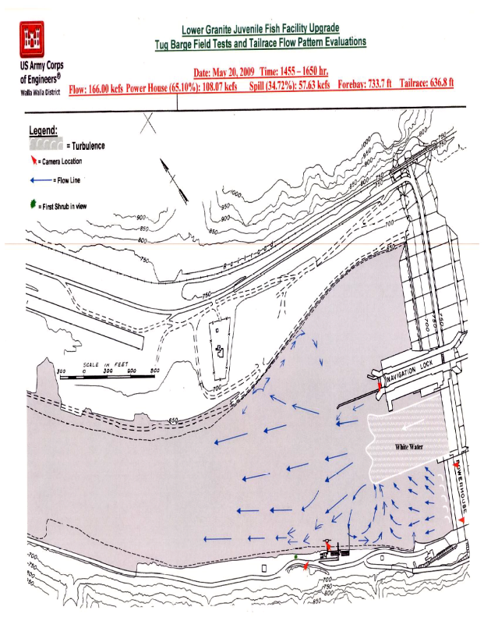

Figure E. 2009 field test tailrace flow pattern evaluation at Lower Granite. This figure represents a high flow condition spill event in May. LGR spring operations spill 20 kcfs 24 hours; TDG fish cap ~ 41 kcfs. Eddy on the north shore with an inflection point about 900 - 1,000 feet downstream of the navigation lock guide wall and an upstream extent near the downstream end of the navigation lock guide wall.

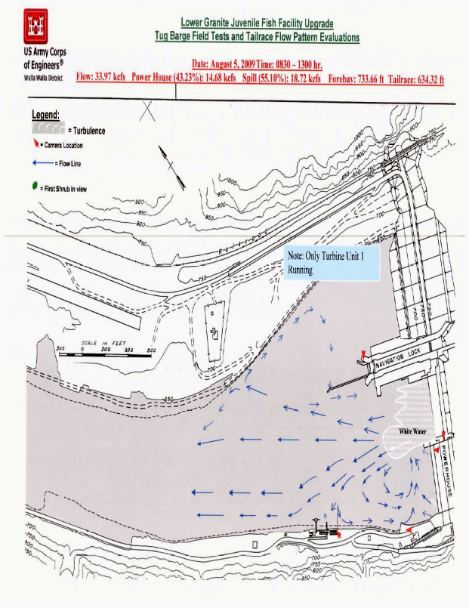

Figure F. 2009 field test tailrace flow pattern evaluation at Lower Granite Dam. This figure represents a low flow condition spill event during August. LGR summer operations spill 18 kcfs; TDG fish cap ~ 41 kcfs. The back eddy flow does not extend all the way to the toe of the dam where the proposed work will take place.

